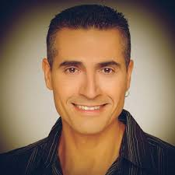Today we look at two dances choreographed by Gadi Bitton. Anyone doing modern Israeli dance has danced to a Bitton Choreography.

Bitton apparently is a very private person as information about him is hard to find. However, information about his dance choreography is very easy to find using Aura Lipski’s database. She references a 1984 dance accredited to him although it appears that he really didn’t start to choreograph full time until 1990. Below is a list of his dance choreographies since 2016 which includes **Israel Sheli**, the dance we videoed several weeks ago.

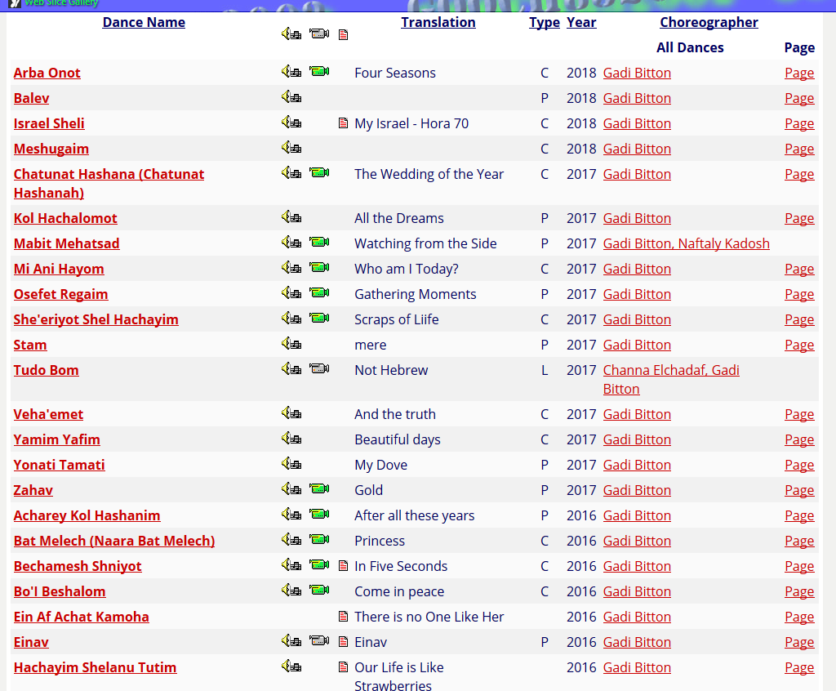

Gadi runs his own dance sessions in Israel (left) and is a regular at many Israeli dance workshops every year (right)

|  |  |
| --- | --- |
| **Sessions:**  Sunday: HaYovel Hall, Kefar Saba  Tuesday: Beit Dani, Tel Aviv  Thursday: Tel Aviv University at the Sports Center | **Workshops**  Hilulim  [Beketzev Acher](https://www.eventbrite.com/e/beketzev-acher-2018-register-and-order-tickets-below-tickets-40043011726?aff=erellivmlt) March 8 – 11, 2018; Oak Brook, IL  Punte Del Este, Chile August  Macholhungaria: Aug 29 through Sept 2 |

On April 19, 2018, Israel celebrated its 70th year of independence. This celebration has become known as Israel 70. Celebrations have occurred in this country in many Jewish settings, including Israeli dance sessions. In Israel, a special song, **Israel Sheli**, commemorating this event, has been released composed by Oren Gispin, lyrics by Yosi Gispin with singing by Lior Narkis and Yardena Arazi. For those interested, Yosi Gispin is also a prolific composer with some 20 or so of his compositions ending up as Israeli dances although at present none are done in the Philly regional Israeli dance sessions.

The choreographer of this dance is Gadi Bitton and he extended an invitation to all the worldwide Israeli dance sessions to film their rendition of the dance and send it to him for inclusion in a proposed video. The participants here today should be aware of this dance given that for several weeks we were practicing this dance before taking a video. Germantown was not alone on this as it was being done worldwide.

In the Philadelphia area, four groups were practicing this dance:

|  |  |
| --- | --- |
| The Monday Beth Sholom session in Elkins Park. This session is run by Talma, Marek and Rob. Two video were done on the evening of April 2nd. The video of record was recorded by Arie, apparently balancing on several chairs. |  |
| The Tuesday session at Temple Beth Sholom in Cherry Hill. This session is run by Sharon Polsky. During the session of April 10, the dance was videotaped twice. The video done by Les Grunes became the video of record. |  |
| The Thursday session at Adath Israel in Bala Cynwyd. This session is led by Don Schillinger. An attempted taping was done on April 19, but was scrapped. |  |
| Our class on Sunday at the Germantown Jewish Centre. This session is led by Grant Shulman. During the session, this dance was videoed twice by Yona Dansky with the second taping the video of record. |  |

In the end, all but the Thursday session videoed the dance. Beth Sholom is part of Gadi’s composite videotape of the dance being done around the world. Temple Beth Sholom became a part of a Maurice Perez video also showing the dance done worldwide.

The Vocabulary of **Yisrael Sheli**

|  |  |  |
| --- | --- | --- |
| **Perach bamidbar** | , פרח במדבר | **A flower in the desert,** |
| **Zayit, chitah, seorah vegam dvash, Rimon te'ena vetamar.** | זית, חיטה, שעורה וגם דבש. רימון, תאנה ותמר. | **Olives, wheat, barley and also honey, Pomegranate, fig and dates.** |
| **Hayom yom huledet vechag,** | היום יום הולדת וחג | **Today is a birthday and a holiday** |
| **Le'eretz avotai,** | לארץ אבותי | **For the land of my forefathers.** |
| **Sovu maagalim** | סובו מעגלים | **Circles go round and round** |
| **Mi zo chogeget beh ayin shanim?** | מי זו חוגגת בעין שנים | **Who is celebrating seventy years?** |
| **Israel sheli** | ישראל שלי | **My Israel** |
| **Hadliku ha'orot** | הדליקו האורות | **Light all the lights** |
| **Shiru bakikarot** | שירו בכיכרות | **Sing in the squares.** |
| **Shavnu elayich lekan,** | שבנו אלייך לכאן | **We've returned to you here** |
| **Banu livnot bach velehibanot** | באנו לבנות בך ולהיבנות | **We came to build and to be built,** |
| **Degel kachol V’lavan** | דגל כחול ולבן | **A blue and white flag,** |
| **Magen David simlech,** | מגן דוד סמלך | **A Star of David your symbol,** |
| **Yerushalaim birah le'olam,** | ירושלים בירה לעולם | **Jerusalem your eternal capital** |

**Yisrael Sheli** Lyrics

|  |  |  |  |  |
| --- | --- | --- | --- | --- |
| **Verse 1**   |  | | --- | | **Eretz shamayim vayam,**  **Perach bamidbar,**  **Zayit, chitah, seorah vegam dvash,**  **Rimon te'ena vetamar.**  **Hayom yom huledet vechag,**  **Le'eretz avotai,**  **Behora sochevet netze babmachol,**  **Beyachad nashir ad bli dai.**  *Chorus:*  **Sovu maagalim**  **Shiru lahilulim**  **Mi zo chogeget beh ayin shanim?**  **Israel sheli!**  **Hadliku ha'orot**  **Shiru bakikarot**  **Hanifu lemaala et kol hadgalim,**  **Israel sheli!**  *Verse 2:*  **Shavnu elayich lekan,**  **Miketzvei tevel,**  **Banu livnot bach velehibanot,**  **Eretz Israel.**  **Degel kachol V’lavan,**  **Magen David simlech,**  **Yerushalaim birah le'olam,**  **nezer shel or leroshech.**  *Chorus*  **Sovu maagalim**  **Shiru lahilulim**  **Mi zo chogeget beh ayin shanim?**  **Israel sheli!**  **Hadliku ha'orot**  **Shiru bakikarot**  **Hanifu lemaala et kol hadgalim,**  **Israel sheli!** | |  | | ארץ שמיים וים  , פרח במדבר  זית, חיטה, שעורה  וגם דבש.  רימון, תאנה ותמר.  היום יום הולדת וחג  לארץ אבותי  בהורה סוחפת נצא במחול  ויחד נשיר עד בלי די.  Chorus  סובו מעגלים,  שירו לה הילולים  מי זו חוגגת בעין שנים,  ישראל שלי.  הדליקו האורות,  שירו בכיכרות  הניפו למעלה את כל הדגלים,  ישראל שלי.  שבנו אלייך לכאן,  מקצווי תבל  באנו לבנות בך ולהיבנות,  ארץ ישראל.  דגל כחול ולבן,  מגן דוד סמלך  ירושלים בירה לעולם,  נזר של אור לראשך.  Chorus  סובו מעגלים,  שירו לה הילולים  מי זו חוגגת בעין שנים,  ישראל שלי.  הדליקו האורות,  שירו בכיכרות  הניפו למעלה את כל הדגלים,  ישראל שלי | **Verse 1**  **Land of sky and sea,**  **A flower in the desert,**  **Olives, wheat, barley and also honey,**  **Pomegranate, fig and dates.**  **Today is a birthday and a holiday**  **For the land of my forefathers.**  **In a sweeping hora we’ll break out in dance.**  **Together we’ll sing with no end.**  **Chorus:**  **Circles go round and round**  **Sing for the reveling.**  **Who is celebrating seventy years?**  **My Israel!**  **Light all the lights**  **Sing in the squares.**  **Raise up the flags**  **My Israel!**  **Verse 2:**  **We've returned to you here**  **From all corners of the world**  **We came to build and to be built,**  **Land of Israel.**  **A blue and white flag,**  **A Star of David your symbol,**  **Jerusalem your eternal capital,**  **A wreath of light on your head.**  **Chorus**  **Circles go round and round**  **Sing for the reveling.**  **Who is celebrating seventy years?**  **My Israel!**  **Light all the lights**  **Sing in the squares.**  **Raise up the flags**  **My Israel!** |

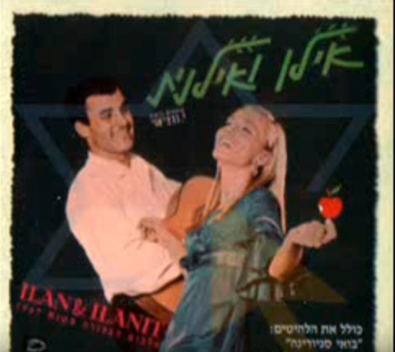Our second song to discuss was composed in 2008 and features one of Israel’s best known female vocalists whose career has spanned 5 (if not more) decades. Born as Hanna Dresner-Tzakh in 1947 in what was then the British protectorate of Palestine, Hannah moved with her parents to Brazil where her parents were in the entertainment industry. Hannah moved back to Israel circa 1960. No doubt, this budding entertainer moved between bands until she became a part of a trio, Gidi, Zach, and Hanna, the Zach being the man she would marry. As Gidi left the band, what resulted was the famous duo (in Israeli) of Ilan and Ilanit, one of whose album is to the right.

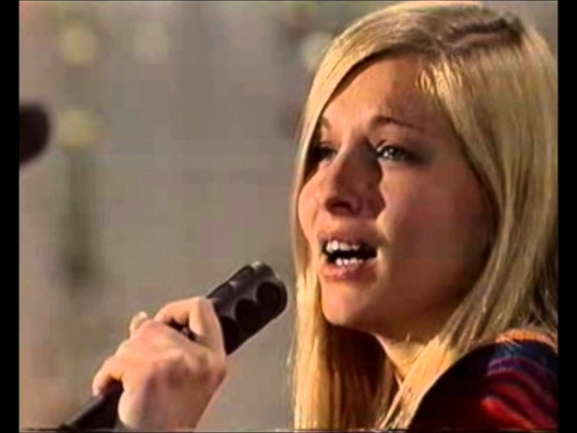In the late 60’s Zach would return to his primary interest, producing records, and we assume the first records he produced was of Ilanit as a solo act. The years between 1971 and 1977 would be this artist’s most productive as we look back in hindsight. First, she was declared Israel’s favorite female singer in each of these years and second, she represented Israel in the Eurovision song contests of 1973 and 1977. Her 1973 appearance – we think the picture to the right was taken as she was performing - was the first for an Israeli entrant and she (and the song) finished fourth. That year’s song, Ey Sham (translated as Somewhere) in itself has an interesting lineage having been composed by Nurit Hirsh, considered by many as Israel’s greatest female composer (and whose music we often dance to on Sunday mornings). Hirsh accompanied Ilanit to the show that year (the ‘73 Eurovision contest was produced in Luxemburg) where Hirsh led the orchestra accompanying the song.

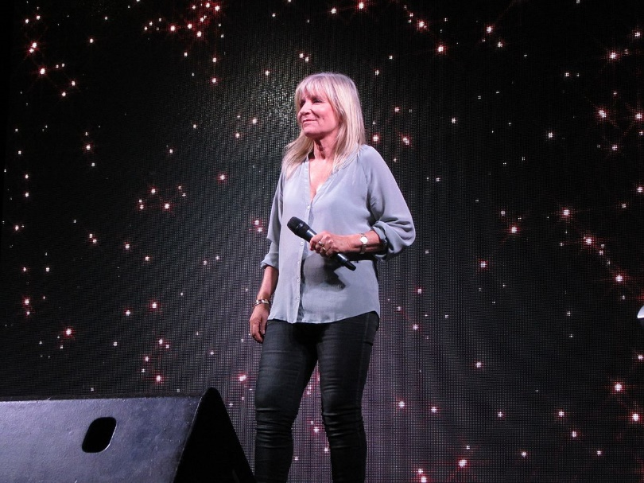Ilanit also was featured in 1977 when Eurovision was in London. She placed 11th in the competition that year. Through the 80’s and most of the 90’s she remained active as a singer. It is said that for a 12 year period – 1996 through 2008 – while she did perform, she did not release any new albums. This drought ended in 2008 with the release of her album, Israelit, whose lead song we will be discussing today

Now, in her 70’s, Ilanit is not as prolific as she once was when younger. However, she still does appearances such as this last picture taken at the 100th anniversary celebration of Hadassah in 2012. [Click here to see Ilanit sing Israelit](http://thediskcoordinator.com/sharon%20may%2013/israeli%20sheli.mp4)

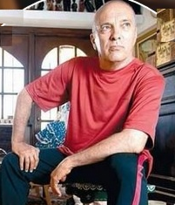Above we discussed Ilanit and her career. However, as you will see when Sharon discusses **Israelit**’s lyrics, the lyrics flow like a poem using great imagery and patriotic fervor. For this, we can thank the lyricist DuDu Barak who, not surprisingly, has written some 9 books of poetry. Recently he finished writing another book [**Forgotten Gleaning: Ungathered Songs of Dudu Barak**](http://aleph.nli.org.il/F/?func=direct&doc_number=003435317&local_base=NNLALL).

Barak was born in 1948 in Jerusalem. Of similar age to Ilanit, he also would have grown up during the various wars of independence. As a youngster, he was a member of a choir that performed on radio programs. Apparently, through these performances, he was introduced to various poets who also were guesting on these programs.

This is a second appearance for Barak in these lectures. In a previous lecture, Barak was mentioned as the lyricist of **Eretz Israel Yafa**, created in 1980, one of the two songs studied during Sharon’s first lecture in Nov’17. In its imagery, the lyrics of both songs encompass patriotism and images of daily life in Israel.

Barak is also the lyricist of several other regionally favorite Israeli dances such as **El Elohey Shamayim** and [**Hanasich Halavan**](http://www.israelidances.com/dance_details.asp?DanceID=346)**.**

**Yisraelit** Significant Lyrics

|  |  |  |
| --- | --- | --- |
| Al katef haChermon | על כתף החרמון | On the shoulder of Mount Hermon, |
| Bepardesel Limon | בפרדסי לימון | In lemon orchards |
| Oranges or grapefruit, | תפוז ואשכולית | Oranges and Grapefruit |
| Al Kos Gdolah Shel Gezer | על כוס גדולה של גזר | With a large glass of carrot juice |
| Keshebetochi Shirei Tasha’ch  Odi Chorazet | כשבתוכי שירי תש"ח,  עודי חורזת | When I am still rhyming  'Songs of the year 1949' |
| Le’or Nerot Hachaq | לאור נרות החג | In the light of holiday candles, |
| Beyom Pkuda O Evel | ביום פקודה או אבל | On days of call to duty or mourning |
| Be’hishama Tzfira Ola | בהישמע צפירה עולה | At the sound of sirens |
| Israelit Balev Ubaneshama | ישראלית בלב ובנשמה | Israeli in heart and soul |
| Bashuk U’bekinyon | בשוק ובקניון | In the market or shopping mall |
| Shamayim,Ve’Elohim echad, umalachei knafayim | שמיים,ואלוהים אחד ,ומלאכי כנפיים | Sky, God, and angels with wings |
| Behamula Klalit | בהמולה כללית | In all that tumult, |
| Befi Tfilat Shalom | בפי תפילת שלום | On my lips a song of peace |
| Kchula Kemo Talit | כחולה כמו טלית | Blue (pure) as a Talit, |

**Yisraelit** Lyrics

|  |  |  |  |  |  |  |
| --- | --- | --- | --- | --- | --- | --- |
| Al katef haChermon,  Beru’ach haglilit  Ani Israelit  Bepardesei limon,  Tapuz ve’eshkolit  Ani Israelit.  Bebeit kafeh katan,  Al kos gdolah shel gezer,  Ani Israelit.  Keshebetochi shirei tasha”ch,  Odi chorezet  Ani Israelit.  Me’al bimot olam,  Be’hofa’ah leilit  Ani Israelit.  Ksheyesh bi tzchok rachav  Vega’avah cheilit  Ani Israelit.  Le’or nerot hachag,  Beyom pkuda o evel,  Be’hishama tzfira ola,  Chalil o nevel  Ani Israelit.  Israelit balev ubaneshama.  B’safat imi Vegam  B’shmi.  B’chalomi ubedami.  Rikud vezemer amami.  Be ima adama.  Bashuk u’bekinyon,  Behamula klalit  Ani Israelit.  Habaita bematos,  Im shir tikvah kalit  Israelit.  Od metzayeret be’einei ruchi:  Shamayim,Ve’Elohim echad, umalachei knafayim  Ani Israelit.  Nosset shirei machar  Lemoshavah gvulit  Ani Israelit.  Befi tfilat shalom,  Kchula kemo tallit  Ani Israelit.  La’ad, lanetzach, mechapeset  et haderech.  La’ad, lanetzach chofshiya ume’usheret  Ani Israelit.  Israelit balev ubaneshama.  B’safat imi Vegam  B’shmi.  B’chalomi ubedami.  Rikud vezemer amami.  Be ima adama.  Befi tfilat shalom,  Kchula kmo talit.  Ani Israelit. | |  |  |  | | --- | --- | --- | | |  |  | | --- | --- | | על כתף החרמון,  ברוח הגלילית  אני ישראלית.  בפרדסי לימון,  תפוז ואשכולית  אני ישראלית.  בבית קפה קטן,  על כוס גדולה של גזר,  אני ישראלית  כשבתוכי שירי תש"ח,  עודי חורזת  אני ישראלית.  מעל בימות עולם,  בהופעה לילית  אני ישראלית.    כשיש בי צחוק רחב  וגאווה חיילית  אני ישראלית.  לאור נרות החג,  ביום פקודה או אבל,  בהישמע צפירה עולה,  חליל או נבל  אני ישראלית.  ישראלית בלב ובנשמה.  בשפת אימי. וגם  בשמי.  בחלומי ובדמי.  ריקוד וזמר עממי.  באמא אדמה.  בשוק ובקניון,  בהמולה כללית  אני ישראלית.  הביתה במטוס,  עם שיר תקווה קליט  אני ישראלית.    עוד מציירת בעיני רוחי:  שמיים,ואלוהים אחד ,ומלאכי כנפיים  אני ישראלית.  נושאת שירי מחר  למושבה גבולית  אני ישראלית.    בפי תפילת שלום,  כחולה כמו טלית  אני ישראלית.    לעד, לנצח, מחפשת את הדרך.  לעד, לנצח, חופשייה ומאושרת  אני ישראלית.  ישראלית בלב ובנשמה.  בשפת אימי. וגם  בשמי.  בחלומי ובדמי.  ריקוד וזמר עממי.  באמא אדמה.  בפי תפילת שלום,  כחולה כמו טלית.  אני ישראלית. |  | | |  | | On the shoulder of Mount Hermon,  On Galilee winds  I am an Israeli.  In lemon orchards,  Oranges and grapefruit,  I am an Israeli.  In a small cafe;  With a large glass of carrot juice,  I am an Israeli.  When I am still rhyming  'Songs of the year 1949'  I am an Israeli.  In nightly appearances  On stages all over the world,  I am an Israeli.  When I am full of laughter  And pride,  I am an Israeli.  In the light of holiday candles,  On days of call to duty or mourning,  At the sound of sirens,  Flute or harp,  I am an Israeli.  Israeli in heart and soul,  In my mother’s language and in my own name,  In my dream and in my blood,  In folk dance and song,  In mother earth,  In the market or shopping mall,  In all that tumult,  I am an Israeli.  On the flight home  With a catchy song of hope,  I am an Israeli.  Painting in my imagination:  Sky, God, and  angels with wings,  I am an Israeli.  Carrying songs of tomorrow  To a frontier settlement,  I am an Israeli  On my lips a song of peace,  Blue (pure) as a Talit, I am an Israeli.  Forever, to eternity looking for the way.  Forever, to eternity free  and fulfilled.  I am an Israeli.  Israeli in heart and soul,  In my mother’s language and in my own name,  In my dream and in my blood,  In folk dance and song,  In mother earth,  On my lips, a song of peace  Blue as a tallit,  I am an Israeli |